My profile

Xiaoran Peng(Stella Peng) is a second year master student in University of Michigan major in Electrical and Computer Engineering graduated from Fudan University. Her interest includes machine learning, artificial intelligence and related software development. Also she is passionate about new technology, willing to play in teams and highly self-motivated.

Now she is looking for a full time job related to her interests.



Her programming experience

How to fulfill a complex Sudoku less in 1s



How to beat others in tic-tac-toe every time



How to make Mona Lisa smile wider



How to find the trend of the Hep A infectious population in Michigan

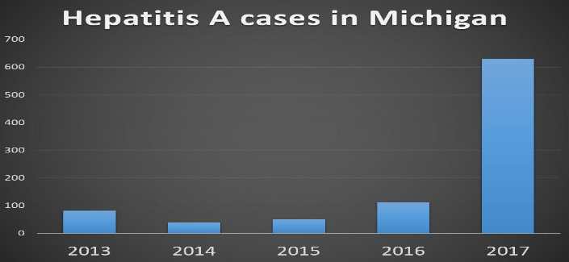

Let’s know about markov decision process

How to design a little database/ make your first IOS app

Back to Fudan

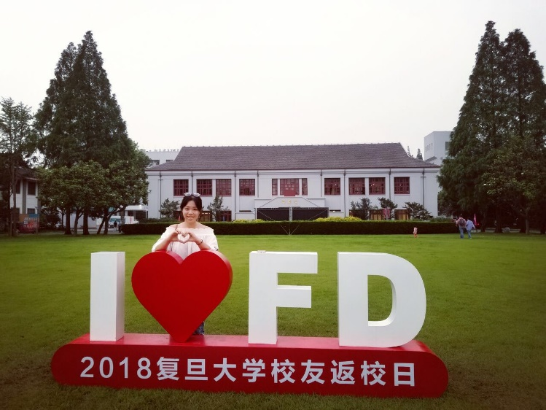

Her research in superconductor

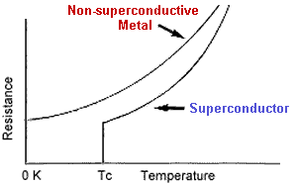

Her research in solar system

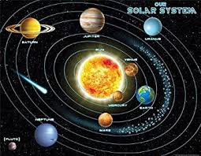

My fun life

My friends



Travelling experience

The queen of card game

Cosplay

Teaching experience in a remote village